RNN

**Popular Neural Networks**

* Feed forward NN-Used in general regression and classification problems
* CNN-Used for image recognition
* DNN-Used for acoustic modelling
* Deep belief network-Used for cancer detection
* RNN-Used for speech/text recognition

**Feed Forward Neural Network**

* The information flows only in forward direction, from the input nodes, through the hidden layers and to the o/p nodes . There are no cycles or loops in the network.
* Decisions are based on the current input
* No memory about the past
* No future scope

**Why RNN??**

* Can’t handle sequential data
* Considers only current input
* Can’t memorize previous inputs

**Applications Of RNN**

* Image Captioning
* Time Series prediction
* NLP
* Machine Translation

**Why Not Feed forward Networks?**

* Consider an image classification use-case where you have trained the neural network to classify images of various animals.
* So, let’s say you feed in an image of a cat or a dog, the network actually provides an output with a corresponding label to the image of a cat or a dog respectively.
* Consider the following diagram:

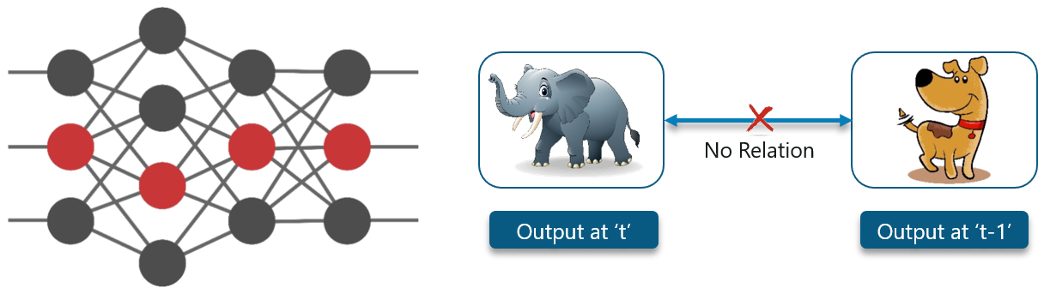

* Here, the first output being an elephant will have no influence of the previous output which was a dog. This means that output at time‘t’ is independent of output at time t-1’.
* Consider this scenario where you will require the use of the previously obtained output:

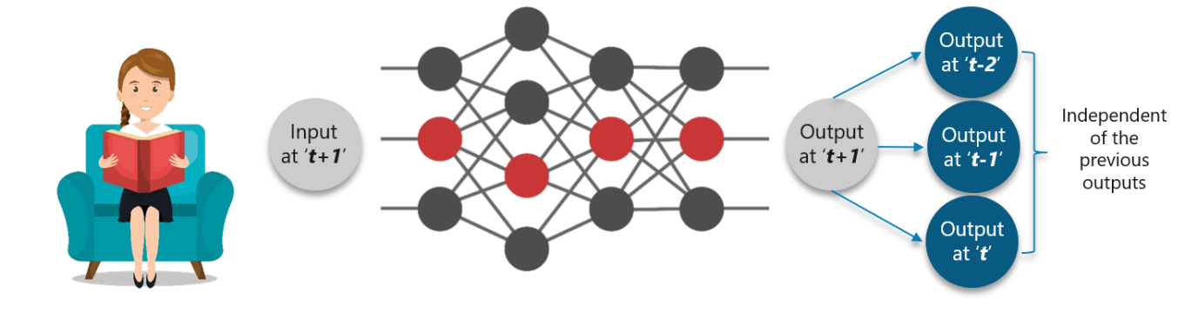

* The concept is similar to reading a book. With every page you move forward into, you need the understanding of the previous pages to make complete sense of the information ahead in most of the cases.
* With a feed-forward network the new output at time‘t+1’ has no relation with outputs at either time t, t-1 or t-2.
* So, feed-forward networks cannot be used when predicting a word in a sentence as it will have no absolute relation with the previous set of words.
* But, with Recurrent Neural Networks, this challenge can be overcome.
* Consider the following diagram:

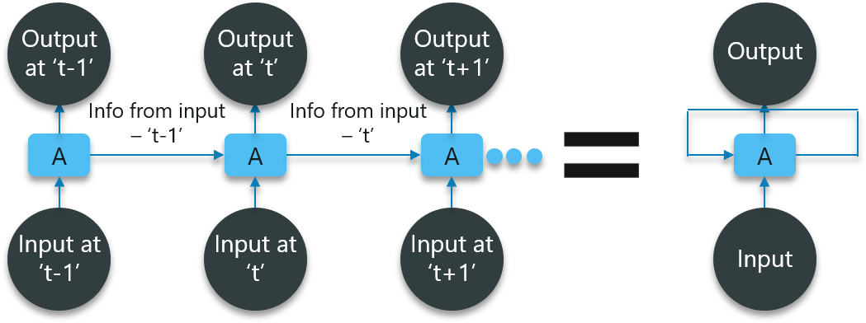

* In the above diagram, we have certain inputs at ‘t-1’ which is fed into the network. These inputs will lead to corresponding outputs at time ‘t-1’ as well.
* At the next timestamp, information from the previous input ‘t-1’ is provided along with the input at ‘t’ to eventually provide the output at ‘t’ as well.
* This process repeats, to ensure that the latest inputs are aware and can use the information from the previous timestamp is obtained.

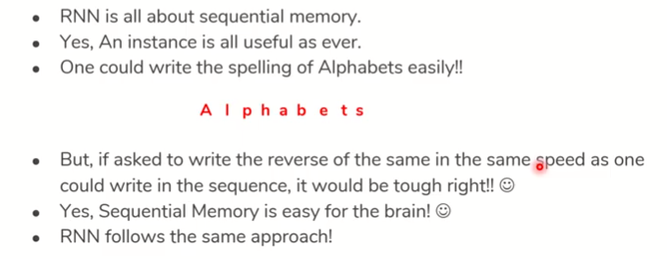

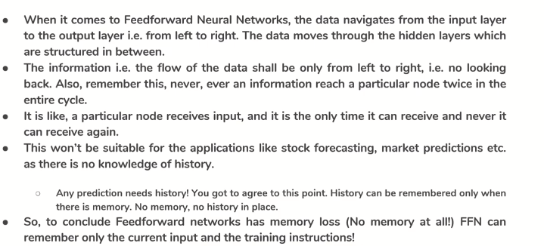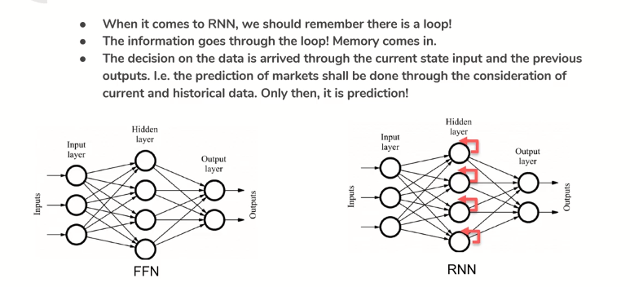

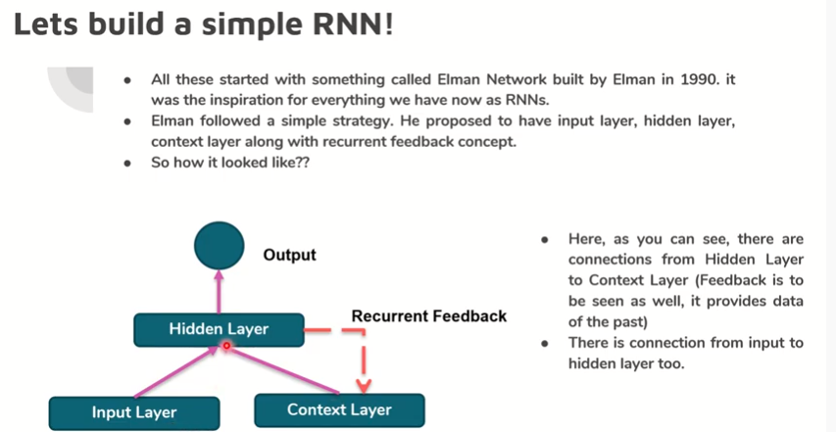

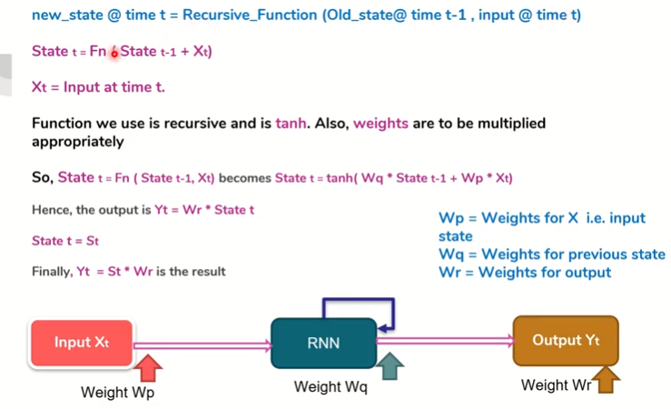

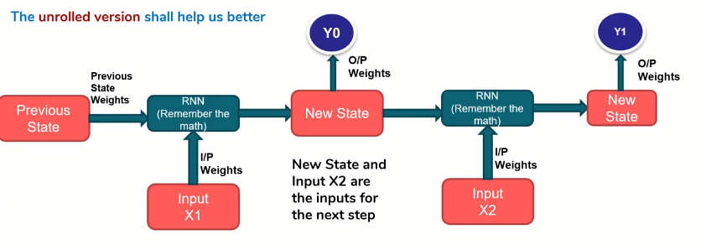

**What Are Recurrent Neural Networks?**

Part-1

Recurrent Networks are a type of artificial neural network designed to recognize patterns in sequences of data, such as text, genomes, handwriting, the spoken word, numerical times series data emanating from sensors, stock markets and government agencies.

* If a model is trained based on the data it can obtain from the previous exercises, the output from the model will be extremely accurate.
* Let us check out the math behind the working of the neural network. Consider the following diagram:

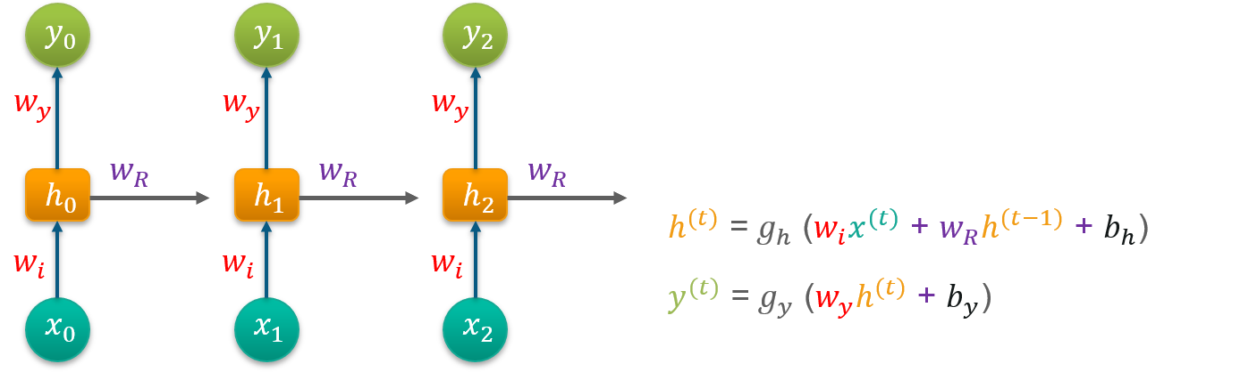

* Consider ‘w’ to be the weight matrix and ‘b’ being the bias:
* At time t=0, input is  ‘x0’ and the task is to figure out what is ‘h0’. Substituting t=0 in the equation and obtaining the function h(t) value. Next, the value of ‘y0’ is found out using the previously calculated values when applied to the new formula.
* This process is repeated through all of the timestamps in the model to train a model.

Part-2

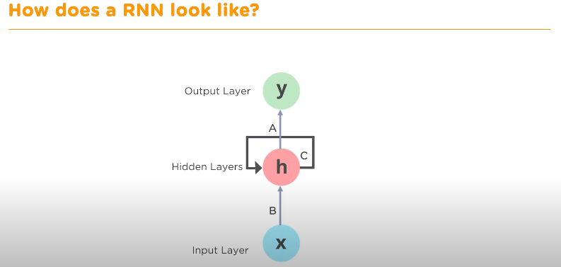

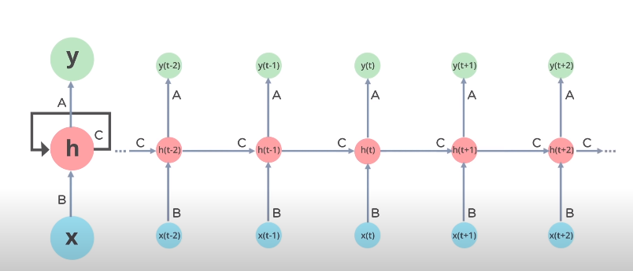

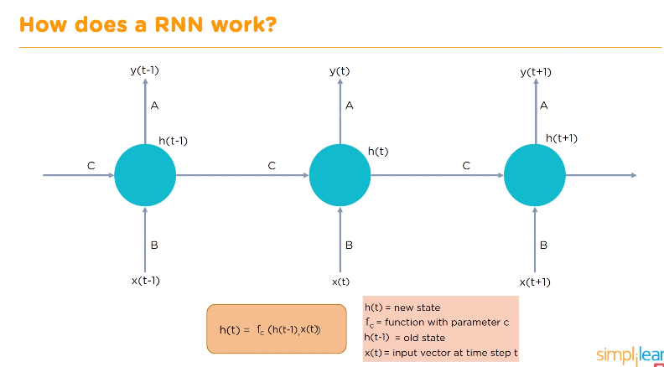

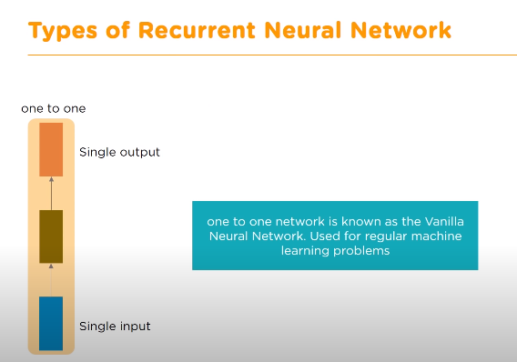

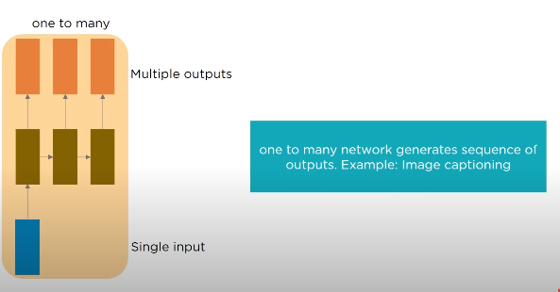

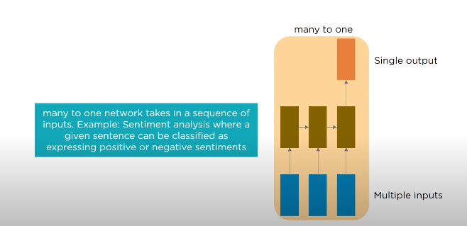

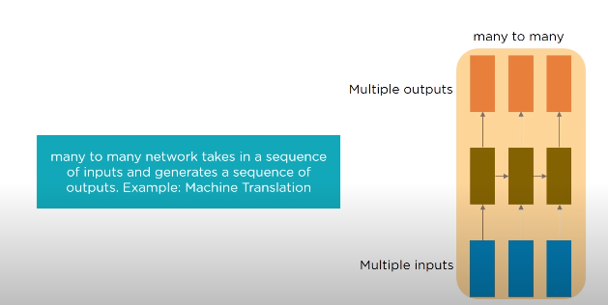

**Training Recurrent Neural Networks**

Recurrent Neural Networks use back propagation algorithm for training, but it is applied for every timestamp. It is commonly known as Back-propagation Through Time (BTT).

There are some issues with Back-propagation such as:

* Vanishing Gradient
* Exploding Gradient

Vanishing Gradient

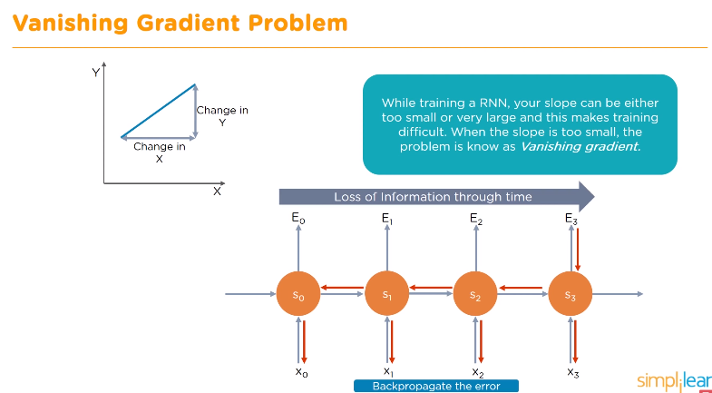

When making use of back-propagation the goal is to calculate the error which is actually found out by finding out the difference between the actual output and the model output and raising that to a power of 2.

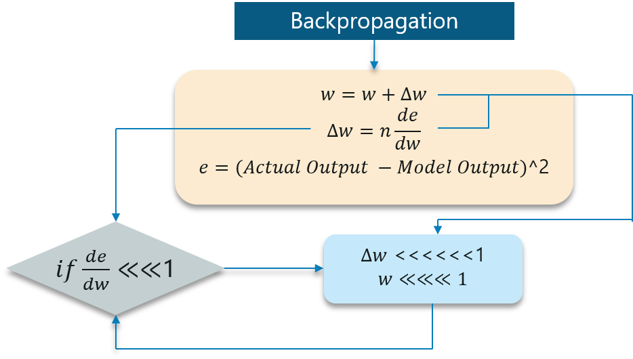

* With the error calculated, the change in the error with respect to the change in the weight is calculated. But with each learning rate, this has to be multiplied with the same.
* So, the product of the learning rate with the change leads to the value which is the actual change in the weight.
* This change in weight is added to the old set of weights for every training iteration as shown in the figure. The issue here is when the change in weight is multiplied, the value is very less.
* Consider you are predicting a sentence say,“I am going to France” and you want to predict “I am going to France, the language spoken there is _____”
* A lot of iterations will cause the new weights to be extremely negligible and this leads to the weights not being updated.

Exploding Gradient

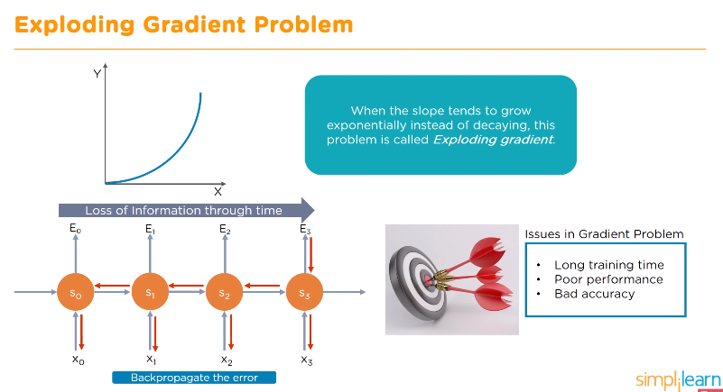

* The working of the exploding gradient is similar but the weights here change drastically instead of negligible change. Notice the small change in the diagram below:
* 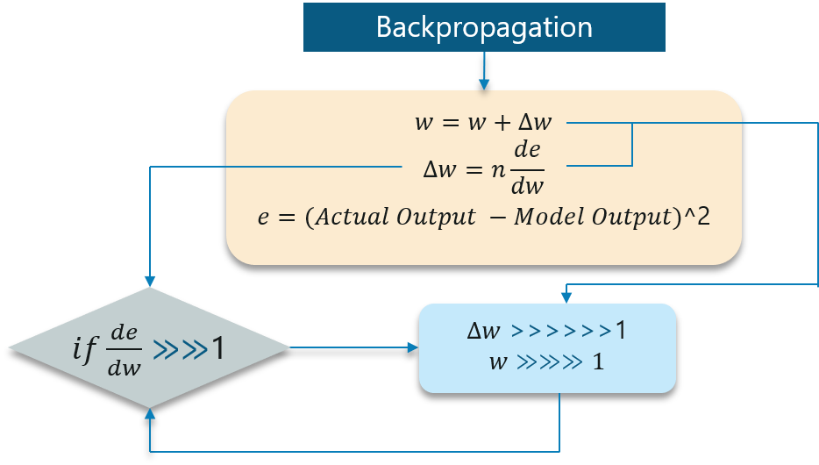

We need to overcome both of these and it is a bit of a challenge at first. Consider the following chart:

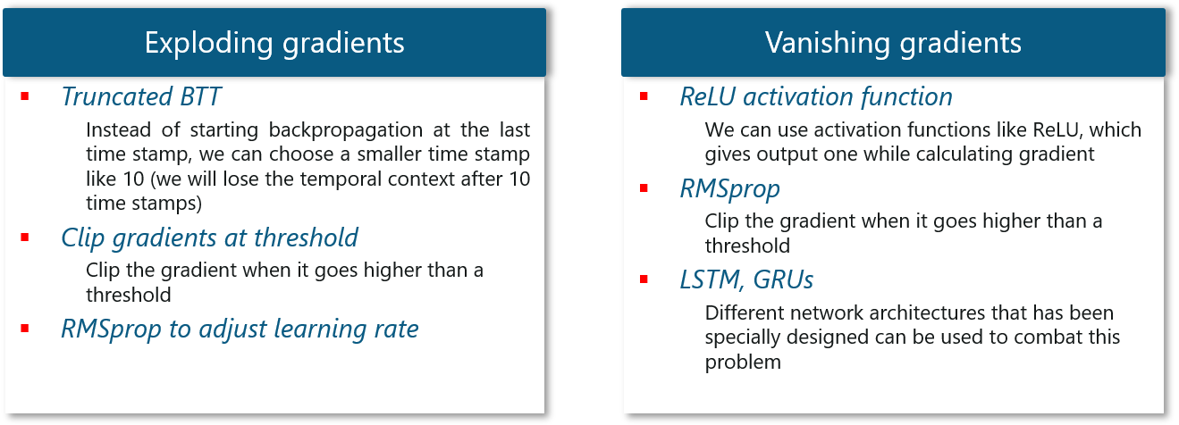

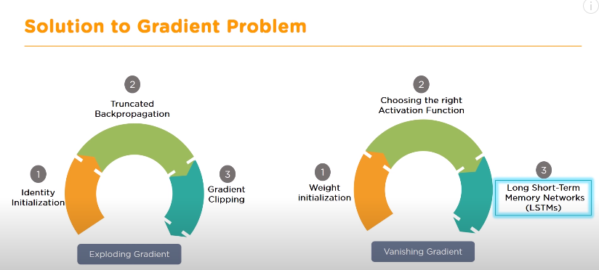

**Unidirectional RNN**

**Bidirectional RNN**

**Deep RNN**

**Back Propagation Through Time**

**Different Types Of RNN**

**GRU(Gated Recurrent Units)**

GRU unit does not have to use a memory unit to control the flow of information like the LSTM unit. It can directly makes use of the all hidden states without any control. GRUs have fewer parameters and thus may train a bit faster or need less data to generalize. But, with large data, the LSTMs with higher expressiveness may lead to better results.

They are almost similar to LSTMs except that they have two gates: reset gate and update gate. Reset gate determines how to combine new input to previous memory and update gate determines how much of the previous state to keep. Update gate in GRU is what input gate and forget gate were in LSTM. We don't have the second non linearity in GRU before calculating the output, .neither they have the output gate.

GRU couples forget as well as input gates. GRU use less training parameters and therefore use less memory, execute faster and train faster than LSTM's whereas LSTM is more accurate on dataset using longer sequence. In short, if sequence is large or accuracy is very critical, please go for LSTM whereas for less memory consumption and faster operation go for GRU. If you donot have much floating point operations per second (FLOP's) to spare switch to GRU. LSTM has three values at output (output, hidden and cell) whereas GRU has two values at output (output and hidden).

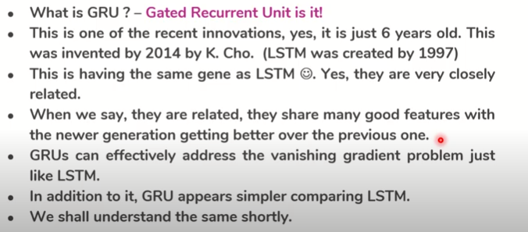

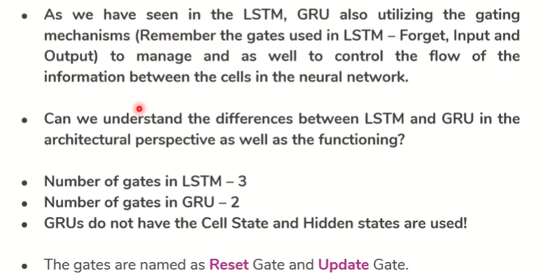

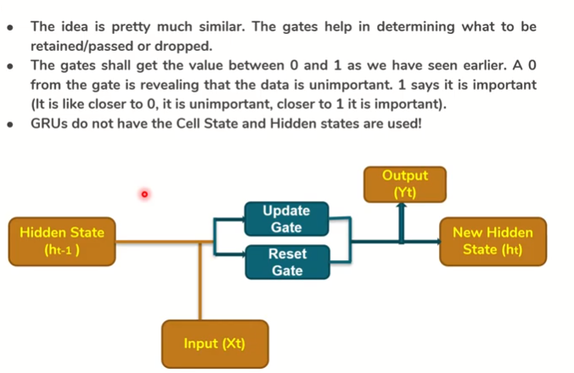

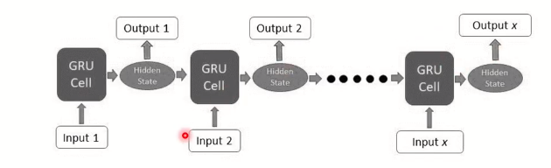

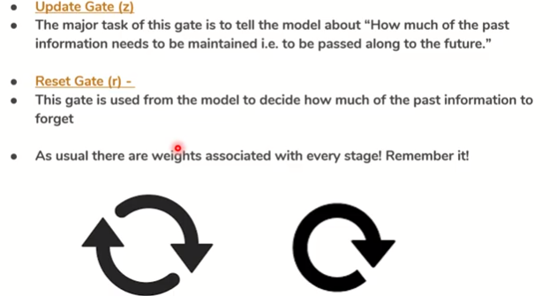

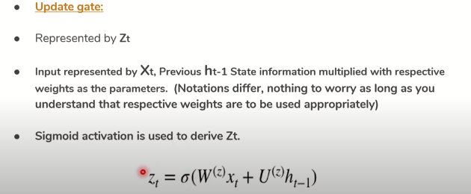

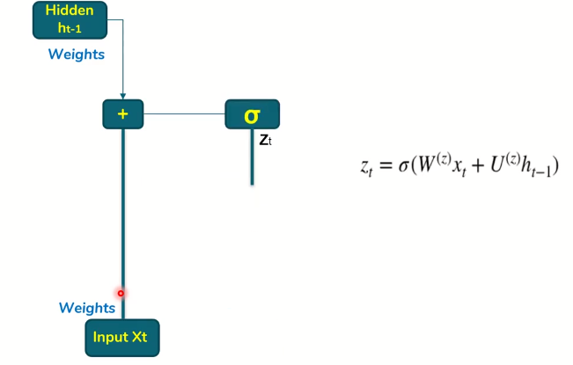

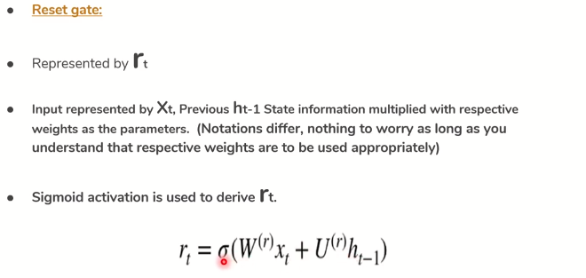

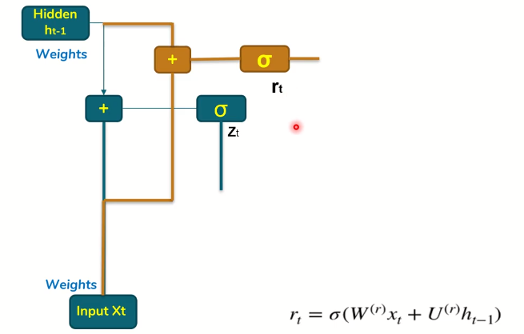

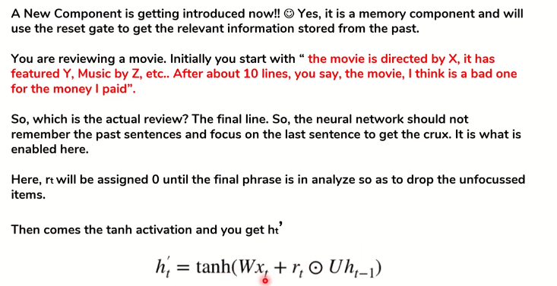

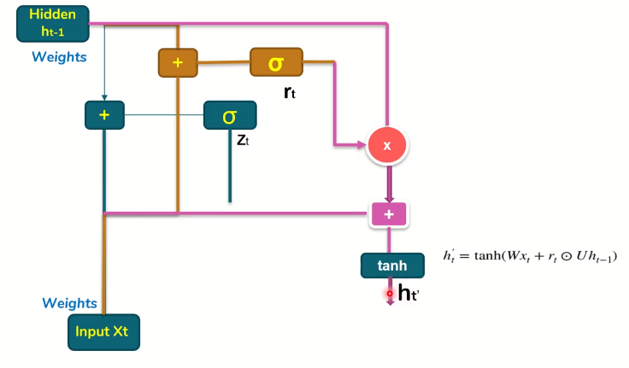

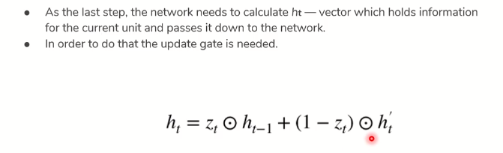

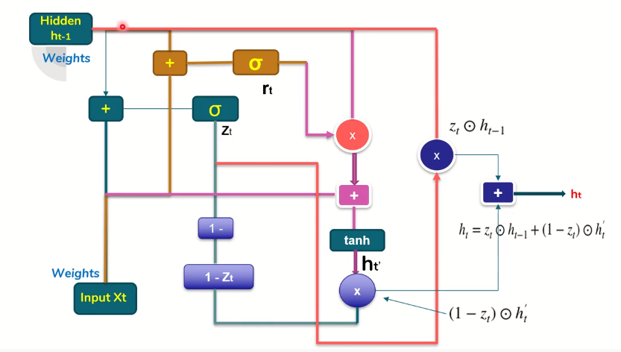

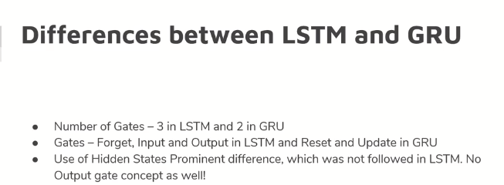

**Long Short-Term Memory Networks**

Long Short-Term Memory networks are usually just called “LSTMs”.

They are a special kind of Recurrent Neural Networks which are capable of learning long-term dependencies.

What are long-term dependencies?

Many times only recent data is needed in a model to perform operations. But there might be a requirement from a data which was obtained in the past.

Let’s look at the following example:

Consider a language model trying to predict the next word based on the previous ones. If we are trying to predict the last word in the sentence say “The clouds are in the sky”.

The context here was pretty simple and the last word ends up being sky all the time. In such cases, the gap between the past information and the current requirement can be bridged really easily by using Recurrent Neural Networks.

So, problems like Vanishing and Exploding Gradients do not exist and this makes LSTM networks handle long-term dependencies easily.

LSTM have chain-like neural network layer. In a standard recurrent neural network, the repeating module consists of one single function as shown in the below figure:

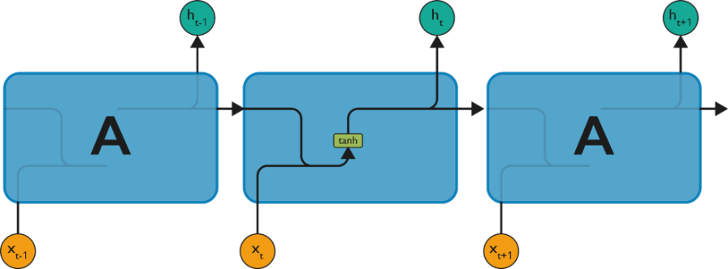

As shown above, there is a tanh function present in the layer. This function is a squashing function. So, what is a squashing function?

It is a function which is basically used in the range of -1 to +1 and to manipulate the values based on the inputs.

let us consider the structure of an LSTM network:

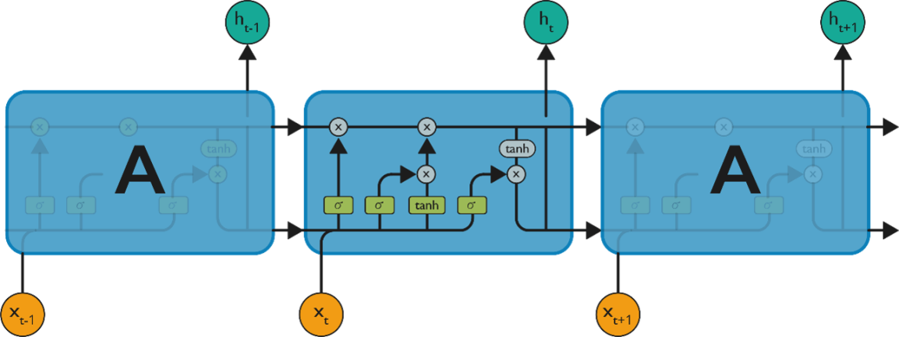

As denoted from the image, each of the functions in the layers has their own structures when it comes to LSTM networks. The cell state is the horizontal line in the figure and it acts like a conveyer belt carrying certain data linearly across the data channel.

**Step 1:**

The first step in the LSTM is to identify that information which is not required and will be thrown away from the cell state. This decision is made by a sigmoid layer called as forget gate layer.

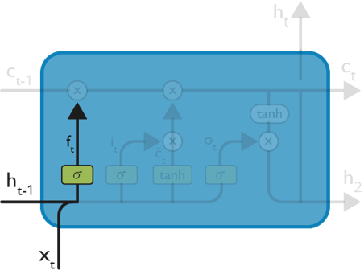

The highlighted layer in the above is the sigmoid layer which is previously mentioned.

The calculation is done by considering the new input and the previous timestamp which eventually leads to the output of a number between 0 and 1 for each number in that cell state.

As typical binary, 1 represents to keep the cell state while 0 represents to trash it.

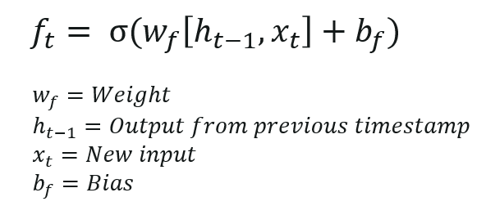

Consider gender classification, it is really important to consider the latest and correct gender when the network is being used.

**Step 2:**

The next step is to decide, what new information we’re going to store in the cell state. This whole process comprises of following steps:

A sigmoid layer called the “input gate layer” decides which values will be updated.

The  tanh layer creates a vector of new candidate values, that could be added to the state.

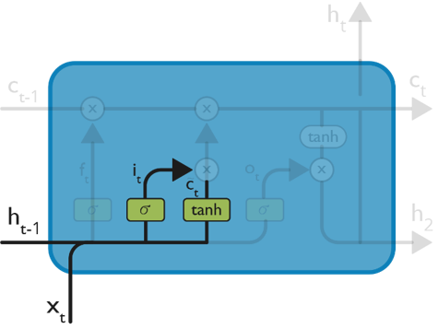

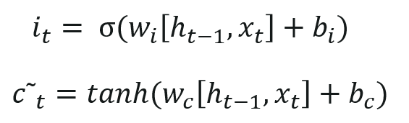

The input from the previous timestamp and the new input are passed through a sigmoid function which gives the value i(t). This value is then multiplied by c(t) and then added to the cell state.

In the next step, these two are combined to update the state.

Step 3:

Now, we will update the old cell state Ct−1, into the new cell state Ct.

First, we multiply the old state (Ct−1) by f(t), forgetting the things we decided to leave behind earlier.

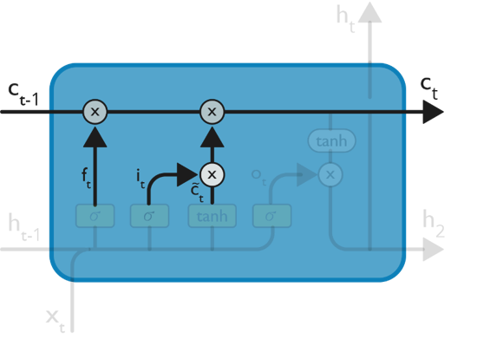

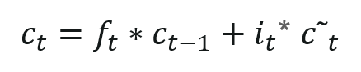

Then, we add i_t* c˜_t. This is the new candidate values, scaled by how much we decided to update each state value.

In the second step, we decided to do make use of the data which is only required at that stage.

In the third step, we actually implement it.

In the language case example which was previously discussed, there is where the old gender would be dropped and the new gender would be considered.

Step 4:

We will run a sigmoid layer which decides what parts of the cell state we’re going to output.

Then, we put the cell state through tanh (push the values to be between −1 and 1)

Later, we multiply it by the output of the sigmoid gate, so that we only output the parts we decided to.

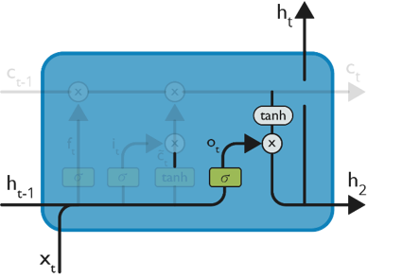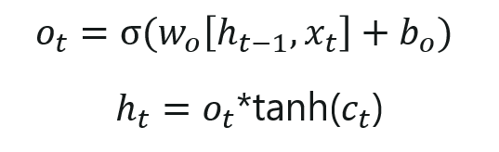

The calculation in this step is pretty much straightforward which eventually leads to the output.

However, the output consists of only the outputs there were decided to be carry forwarded in the previous steps and not all the outputs at once.

Summing up all the 4 steps:

In the first step, we found out what was needed to be dropped.

The second step consisted of what new inputs are added to the network.

The third step was to combine the previously obtained inputs to generate the new cell states.

Lastly, we arrived at the output as per requirement.

Part-2

The three gates are Forget gate, Input Gate, Output Gate, Intermediate Cell state, cell state

Forget Gate

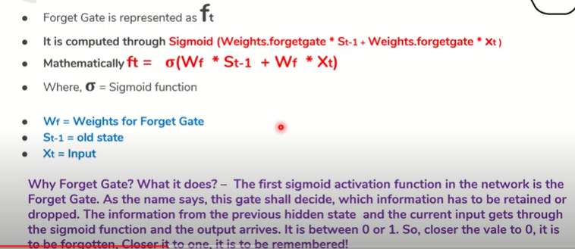

Input Gate

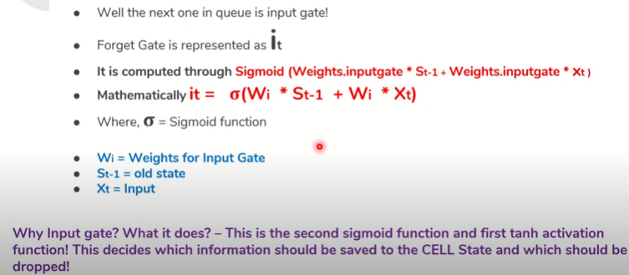

Output Gate

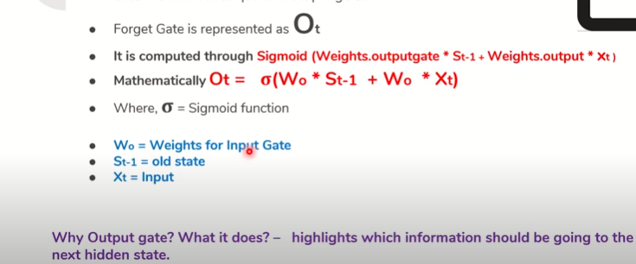

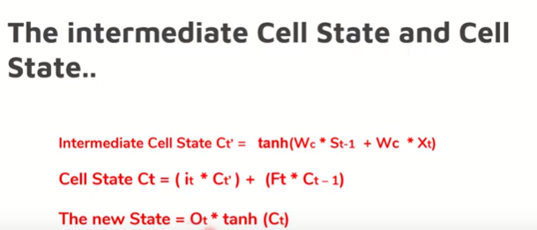

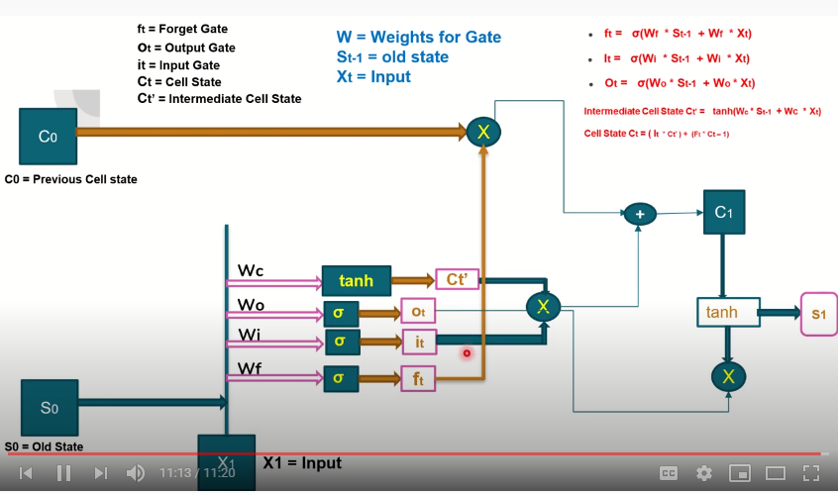

**Applications of RNN**

RNN has multiple uses, especially when it comes to predicting the future. In the financial industry, RNN can be helpful in predicting stock prices or the sign of the stock market direction (i.e., positive or negative).

RNN is useful for an autonomous car as it can avoid a car accident by anticipating the trajectory of the vehicle.

RNN is widely used in text analysis, image captioning, sentiment analysis and machine translation. For example, one can use a movie review to understand the feeling the spectator perceived after watching the movie. Automating this task is very useful when the movie company does not have enough time to review, label, consolidate and analyze the reviews. The machine can do the job with a higher level of accuracy.

**Limitations of RNN**

In theory, RNN is supposed to carry the information up to time . However, it is quite challenging to propagate all this information when the time step is too long. When a network has too many deep layers, it becomes untrainable. This problem is called: **vanishing gradient problem**. If you remember, the neural network updates the weight using the gradient descent algorithm. The gradients grow smaller when the network progress down to lower layers.

In conclusion, the gradients stay constant meaning there is no space for improvement. The model learns from a change in the gradient; this change affects the network's output. However, if the difference in the gradient is too small (i.e., the weights change a little), the network can't learn anything and so the output. Therefore, a network facing a vanishing gradient problem cannot converge toward a good solution.

**Weakness Of RNN**

The weakness of this RNN is that it only uses the information that is earlier in the sequence to make a prediction.

He said, Teddy Roosevelt was a great person. In order to decide Teddy is a part of person’s name it won’t be useful to know not just the information from the first two words but to know the information from later words in the sentence.

**Activation Function**

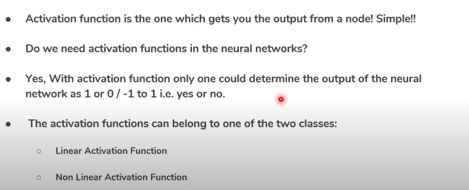

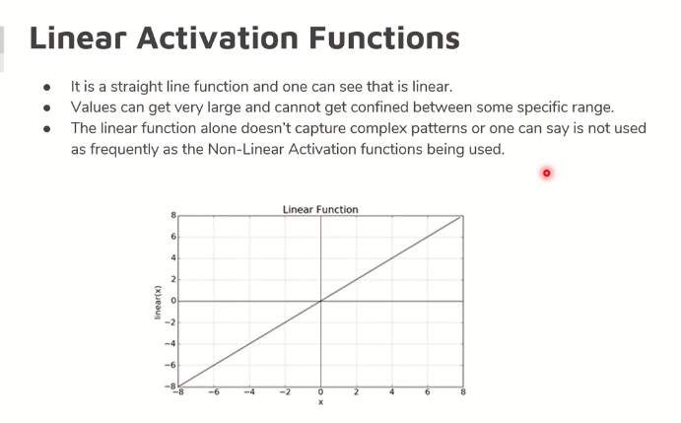

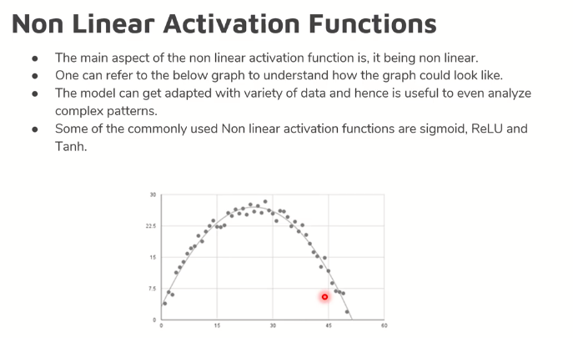

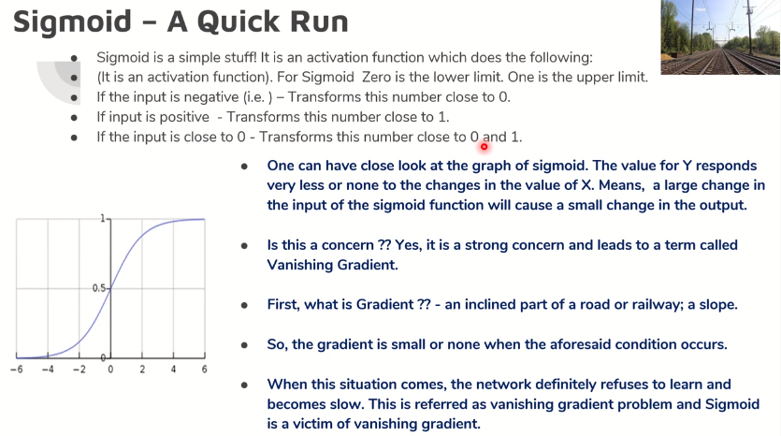

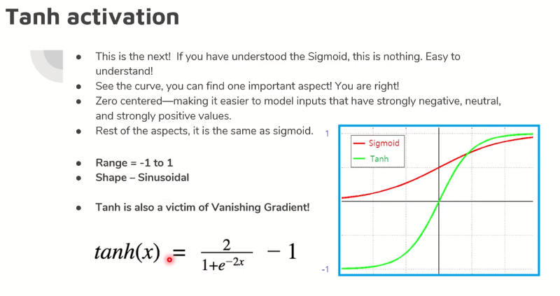

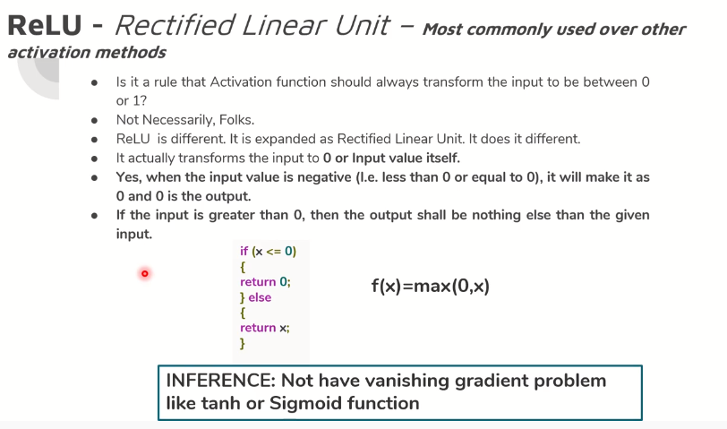

AUTO ENCODERS

* It’s a unsupervised learning technique.
* No explicit labels are required to train the model, raw input is sufficient for training.
* Auto encoders are a specific type of feed forward neural networks where the input is the same as the output. They compress the input into a lower-dimensional code and then reconstruct the output from this representation. The code is a compact “summary” or “compression” of the input, also called the latent-space representation.
* An auto encoder consists of 3 components: encoder, code and decoder. The encoder compresses the input and produces the code, the decoder then reconstructs the input only using this code.

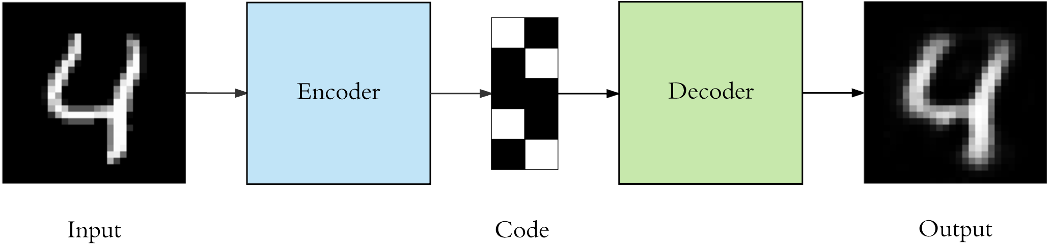

* To build an auto encoder we need 3 things: an encoding method, decoding method, and a loss function to compare the output with the target.

**What are Auto-encoders?**

An autoencoder [neural network](https://www.edureka.co/blog/neural-network-tutorial/) is an [Unsupervised Machine learning](https://www.edureka.co/blog/what-is-machine-learning/) algorithm that applies back propagation, setting the target values to be equal to the inputs. Autoencoders are used to reduce the size of our inputs into a smaller representation. If anyone needs the original data, they can reconstruct it from the compressed data.

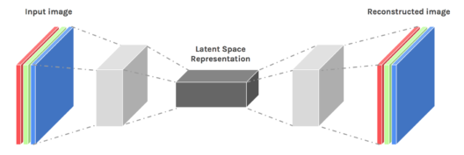

We have a similar machine learning algorithm ie. PCA which does the same task. So you might be thinking why do we need Autoencoders then??

**Autoencoders Tutorial: Its Emergence**

Autoencoders are preferred over PCA because:

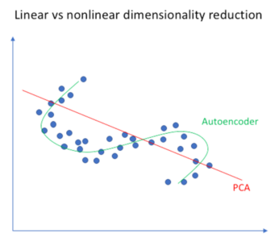

* An autoencoder can learn non-linear transformations with a non-linear activation function and multiple layers.
* It doesn’t have to learn dense layers. It can use convolutional layers to learn which is better for video, image and series data.
* It is more efficient to learn several layers with an autoencoder rather than learn one huge transformation with PCA.
* An autoencoder provides a representation of each layer as the output.
* It can make use of pre-trained layers from another model to apply transfer learning to enhance the encoder/decoder.

Now let’s have a look at a few Industrial Applications of Autoencoders.

**Applications of Autoencoders**

### Image Coloring

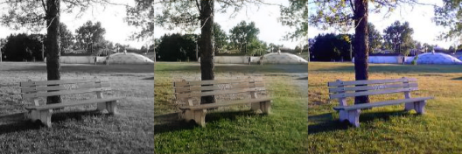

Autoencoders are used for converting any black and white picture into a colored image. Depending on what is in the picture, it is possible to tell what the color should be.

### Autoencoders Tutorial - Feature Variation

### Feature variation

It extracts only the required features of an image and generates the output by removing any noise or unnecessary interruption.

### Autoencoders Tutorial - Dimensionality Reduction

### 

### Dimensionality Reduction

The reconstructed image is the same as our input but with reduced dimensions. It helps in providing the similar image with a reduced pixel value.

### Autoencoders Tutorial - Denoising image

### Denoising Image

The input seen by the autoencoder is not the raw input but a stochastically corrupted version. A denoising autoencoder is thus trained to reconstruct the original input from the noisy version.

### Autoencoders Tutorial - Watermark Removal

### Watermark Removal

It is also used for removing watermarks from images or to remove any object while filming a video or a movie.

**Architecture of Autoencoders**

An Autoencoder consist of three layers:

1. Encoder
2. Code
3. Decoder

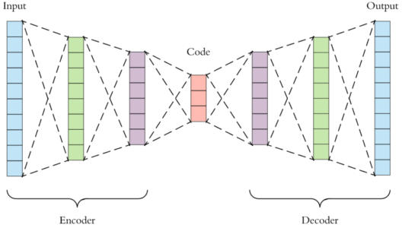

* Encoder: This part of the network compresses the input into a latent space representation. The encoder layer encodes the input image as a compressed representation in a reduced dimension. The compressed image is the distorted version of the original image.
* Code: This part of the network represents the compressed input which is fed to the decoder.
* Decoder: This layer decodes the encoded image back to the original dimension. The decoded image is a lossy reconstruction of the original image and it is reconstructed from the latent space representation.

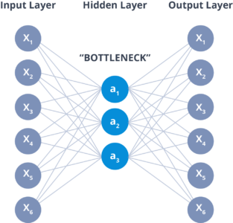

The layer between the encoder and decoder, ie. the code is also known as Bottleneck. This is a well-designed approach to decide which aspects of observed data are relevant information and what aspects can be discarded. It does this by balancing two criteria :

* Compactness of representation, measured as the compressibility.
* It retains some behaviourally relevant variables from the input.

**Properties and Hyperparameters**

Properties of Autoencoders:

* Data-specific: Autoencoders are only able to compress data similar to what they have been trained on.
* Lossy: The decompressed outputs will be degraded compared to the original inputs.
* Learned automatically from examples: It is easy to train specialized instances of the algorithm that will perform well on a specific type of input.

Auto encoders are mainly a dimensionality reduction (or compression) algorithm with a couple of important properties:

* Data-specific: Auto encoders are only able to meaningfully compress data similar to what they have been trained on. Since they learn features specific for the given training data, they are different than a standard data compression algorithm like gzip . So we can’t expect an autoencoder trained on handwritten digits to compress landscape photos.
* Lossy: The output of the auto encoder will not be exactly the same as the input, it will be a close but degraded representation. If you want lossless compression they are not the way to go.
* Unsupervised: To train an autoencoder we don’t need to do anything fancy, just throw the raw input data at it. Autoencoders are considered an unsupervised learning technique since they don’t need explicit labels to train on. But to be more precise they are self-supervised because they generate their own labels from the training data.

# Architecture

 Both the encoder and decoder are fully-connected feed forward neural networks.

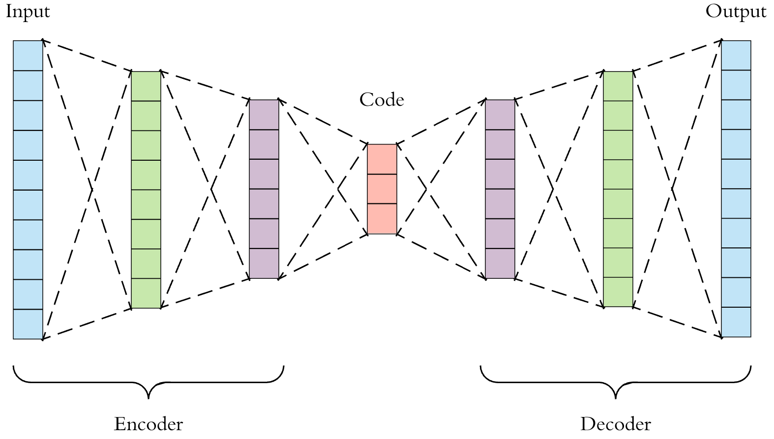

First the input passes through the encoder, which is a fully-connected ANN, to produce the code.  The decoder, which has the similar ANN structure, then produces the output only using the code. The goal is to get an output identical with the input. Note that the decoder architecture is the mirror image of the encoder. This is not a requirement but it’s typically the case. The only requirement is the dimensionality of the input and output needs to be the same. Anything in the middle can be played with.

There are 4 hyper parameters that we need to set before training an autoencoder:

* Code size: number of nodes in the middle layer. Smaller size results in more compression.
* Number of layers: the autoencoder can be as deep as we like. In the figure above we have 2 layers in both the encoder and decoder, without considering the input and output.
* Number of nodes per layer: the autoencoder architecture we’re working on is called a stacked autoencoder since the layers are stacked one after another. Usually stacked autoencoders look like a “sandwitch”. The number of nodes per layer decreases with each subsequent layer of the encoder, and increases back in the decoder. Also the decoder is symmetric to the encoder in terms of layer structure. As noted above this is not necessary and we have total control over these parameters.
* Loss function: we either use mean squared error (mse) or binary crossentropy. If the input values are in the range [0, 1] then we typically use crossentropy, otherwise we use the mean squared error.

Hyperparameters of Autoencoders:

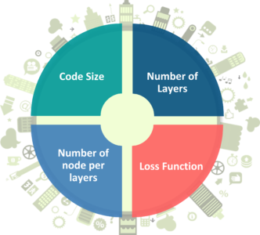

There are 4 hyperparameters that we need to set before training an autoencoder:

* Code size: It represents the number of nodes in the middle layer. Smaller size results in more compression.
* Number of layers: The autoencoder can consist of as many layers as we want.
* Number of nodes per layer: The number of nodes per layer decreases with each subsequent layer of the encoder, and increases back in the decoder. The decoder is symmetric to the encoder in terms of the layer structure.
* Loss function: We either use mean squared error or binary cross-entropy. If the input values are in the range [0, 1] then we typically use cross-entropy, otherwise, we use the mean squared error.
* 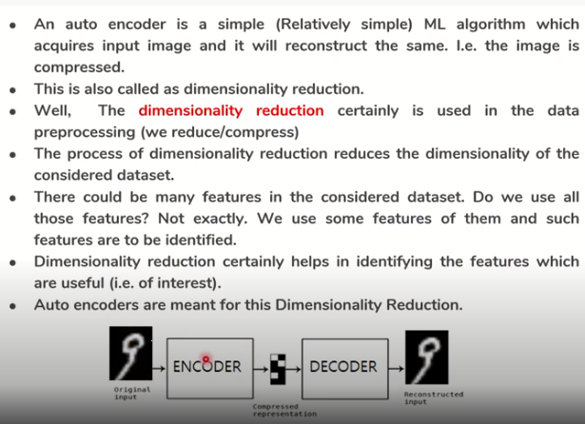

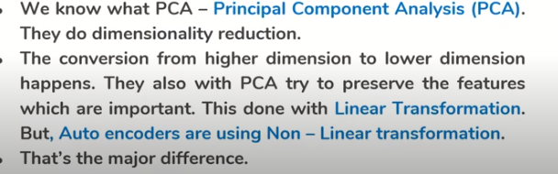

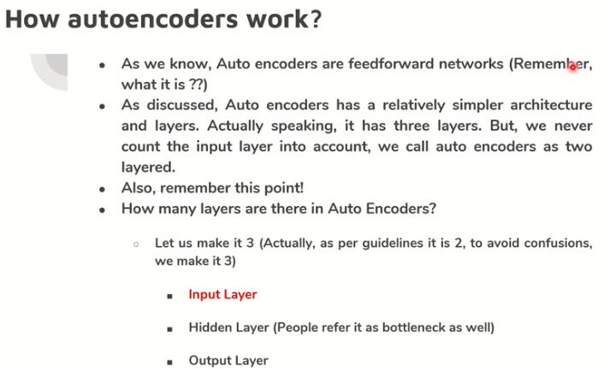

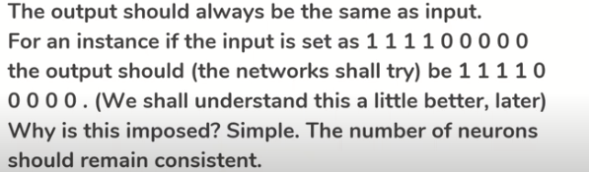

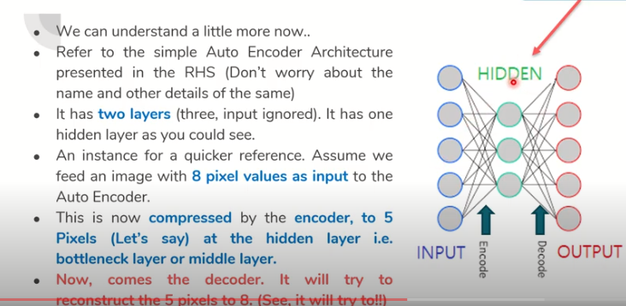

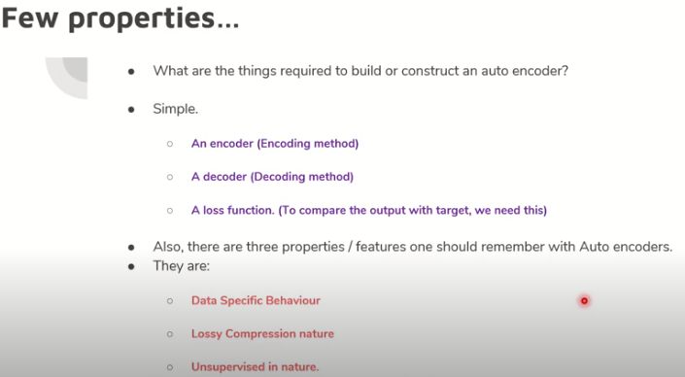

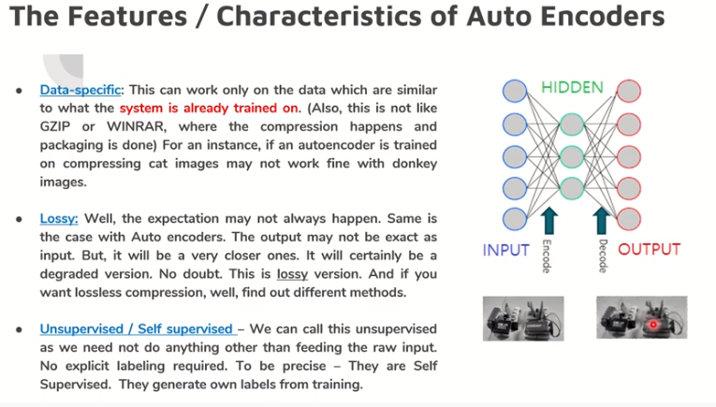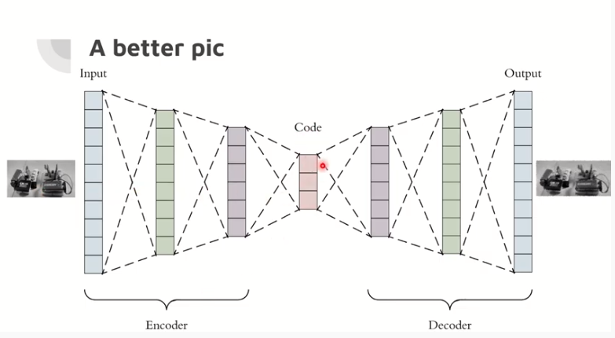

Auto Encoders Types

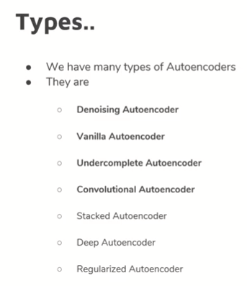

**Types of Autoencoders**

**Convolution Autoencoders**

Autoencoders in their traditional formulation does not take into account the fact that a signal can be seen as a sum of other signals. Convolutional Autoencoders use the convolution operator to exploit this observation. They learn to encode the input in a set of simple signals and then try to reconstruct the input from them, modify the geometry or the reflectance of the image.

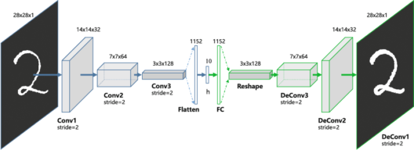

Use cases of CAE:

* Image Reconstruction
* Image Colorization
* latent space clustering
* generating higher resolution image

**Sparse Autoencoders**

* Sparse auto encoders offer us an alternative method for introducing an information bottleneck without requiring a reduction in the number of nodes at our hidden layers. Instead, we’ll construct our loss function such that we penalize activations within a layer.

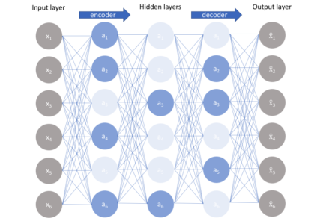

**Deep Autoencoders**

The extension of the simple Autoencoder is the Deep Autoencoder. The first layer of the Deep Autoencoder is used for first-order features in the raw input. The second layer is used for second-order features corresponding to patterns in the appearance of first-order features. Deeper layers of the Deep Autoencoder tend to learn even higher-order features.

A deep autoencoder is composed of two, symmetrical deep-belief networks-

1. First four or five shallow layers representing the encoding half of the net.
2. The second set of four or five layers that make up the decoding half.

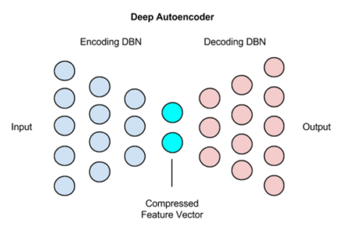

Use cases of Deep Autoencoders

* Image Search
* Data Compression
* Topic Modeling & Information Retrieval (IR)

**Contractive Autoencoders**

* A contractive autoencoder is an unsupervised deep learning technique that helps a neural network encode unlabeled training data. This is accomplished by constructing a loss term which penalizes large derivatives of our hidden layer activations with respect to the input training examples, essentially penalizing instances where a small change in the input leads to a large change in the encoding space.

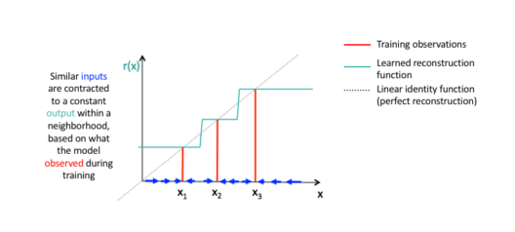

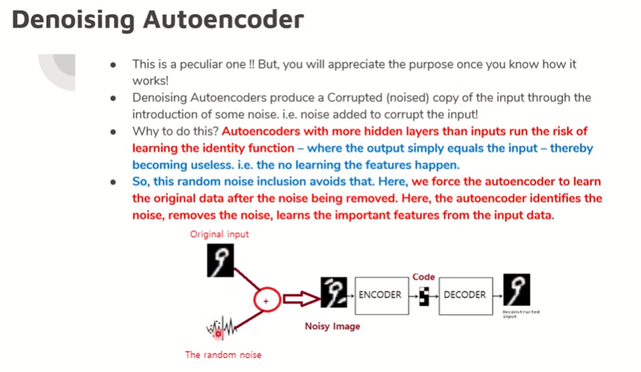

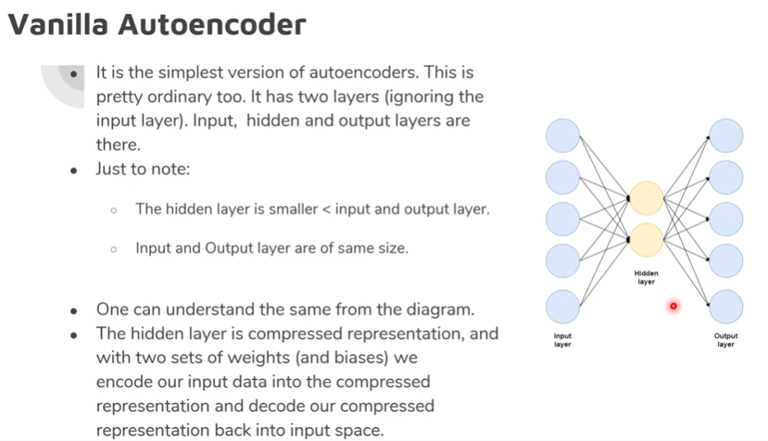

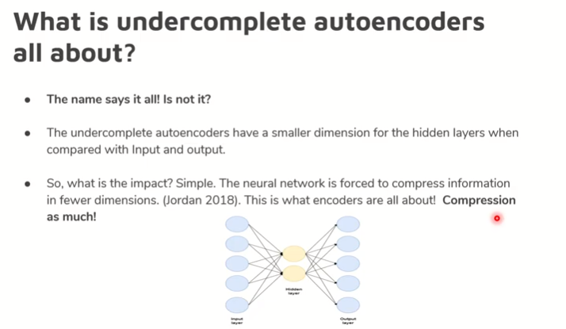

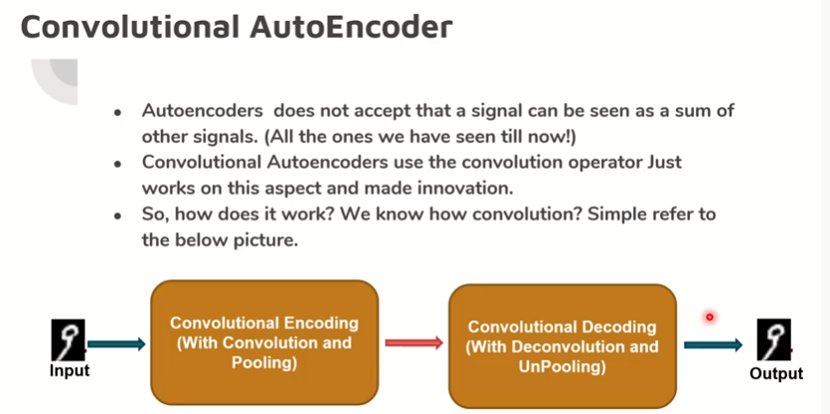

Transfer Learning

Transfer learning is a machine learning method where a model developed for a task is reused as the starting point for a model on a second task.

It is a popular approach in deep learning where pre-trained models are used as the starting point on computer vision and natural language processing tasks given the vast compute and time resources required to develop neural network models on these problems and from the huge jumps in skill that they provide on related problems.

Transfer learning is an optimization that allows rapid progress or improved performance when modeling the second task.

In transfer learning, we first train a base network on a base dataset and task, and then we repurpose the learned features, or transfer them, to a second target network to be trained on a target dataset and task. This process will tend to work if the features are general, meaning suitable to both base and target tasks, instead of specific to the base task.

**How to Use Transfer Learning?**

You can use transfer learning on your own [predictive modeling](https://machinelearningmastery.com/gentle-introduction-to-predictive-modeling/) problems.

Two common approaches are as follows:

1. Develop Model Approach
2. Pre-trained Model Approach

**Develop Model Approach**

**Select Source Task**. You must select a related predictive modeling problem with an abundance of data where there is some relationship in the input data, output data, and/or concepts learned during the mapping from input to output data.

**Develop Source Model**. Next, you must develop a skillful model for this first task. The model must be better than a naive model to ensure that some feature learning has been performed.

**Reuse Model**. The model fit on the source task can then be used as the starting point for a model on the second task of interest. This may involve using all or parts of the model, depending on the modeling technique used.

**Tune Model**. Optionally, the model may need to be adapted or refined on the input-output pair data available for the task of interest.

**Pre-trained Model Approach**

**Select Source Model**. A pre-trained source model is chosen from available models. Many research institutions release models on large and challenging datasets that may be included in the pool of candidate models from which to choose from.

**Reuse Model**. The model pre-trained model can then be used as the starting point for a model on the second task of interest. This may involve using all or parts of the model, depending on the modeling technique used.

**Tune Model**. Optionally, the model may need to be adapted or refined on the input-output pair data available for the task of interest.

**Transfer Learning with Image Data**

It is common to perform transfer learning with predictive modeling problems that use image data as input. This may be a prediction task that takes photographs or video data as input.

For these types of problems, it is common to use a deep learning model pre-trained for a large and challenging image classification task such as the [Image Net](http://www.image-net.org/) 1000-class photograph classification competition.

These models can be downloaded and incorporated directly into new models that expect image data as input.

Three examples of models of this type include:

* [Oxford VGG Model](http://www.robots.ox.ac.uk/~vgg/research/very_deep/)
* [Google Inception Model](https://github.com/tensorflow/models/tree/master/research/inception)
* [Microsoft Res Net Model](https://github.com/KaimingHe/deep-residual-networks)

This approach is effective because the images were trained on a large corpus of photographs and require the model to make predictions on a relatively large number of classes, in turn, requiring that the model efficiently learn to extract features from photographs in order to perform well on the problem.

**Transfer Learning with Language Data**

It is common to perform transfer learning with natural language processing problems that use text as input or output. For these types of problems, a word embedding is used that is a mapping of words to a high-dimensional continuous vector space where different words with a similar meaning have a similar vector representation.

Efficient algorithms exist to learn these distributed word representations and it is common for research organizations to release pre-trained models trained on very large corpora of text documents under a permissive license.

Two examples of models of this type include:

* [Google’s word2vec Model](https://code.google.com/archive/p/word2vec/)
* [Stanford’s GloVe Model](https://nlp.stanford.edu/projects/glove/)

These distributed word representation models can be downloaded and incorporated into deep learning language models in either the interpretation of words as input or the generation of words as output from the model.

**When to Use Transfer Learning?**

Transfer learning is an optimization, a shortcut to saving time or getting better performance.

Three possible benefits to look for when using transfer learning:

1. Higher start. The initial skill (before refining the model) on the source model is higher than it otherwise would be.
2. Higher slope. The rate of improvement of skill during training of the source model is steeper than it otherwise would be.
3. Higher asymptote. The converged skill of the trained model is better than it otherwise would be.

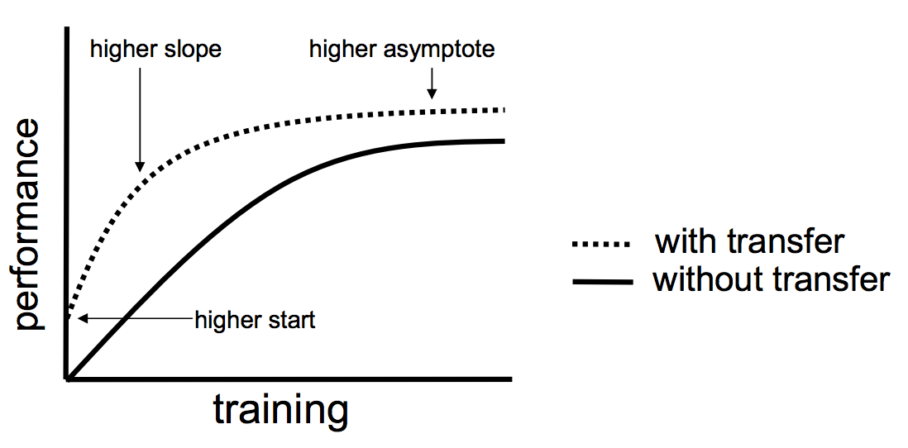

### Pre-trained Models

* [Oxford VGG Model](http://www.robots.ox.ac.uk/~vgg/research/very_deep/)
* [Google Inception Model](https://github.com/tensorflow/models/tree/master/research/inception)
* [Microsoft ResNet Model](https://github.com/KaimingHe/deep-residual-networks)
* [Google’s word2vec Model](https://code.google.com/archive/p/word2vec/)
* [Stanford’s GloVe Model](https://nlp.stanford.edu/projects/glove/)
* [Caffe Model Zoo](https://github.com/BVLC/caffe/wiki/Model-Zoo)